- Write a C program to take any number as user input and check whether it is palindrome or not.

Output:
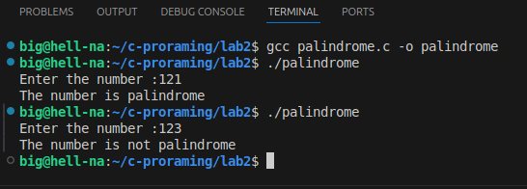

- Write a C program to find a reverse of a number input by the user.

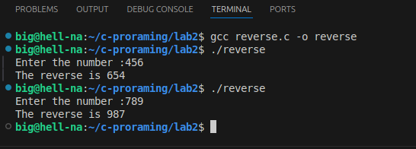

Output:

- Write a C program to take any number as user input and check whether it is Armstrong number or not.

Output:

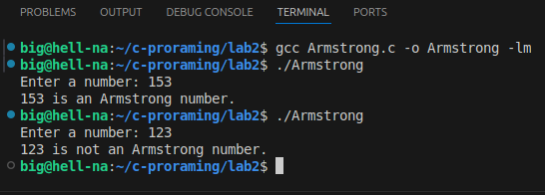

- Write a C program to generate Fibonacci sequence up-to n terms taking n as user input.

Output:
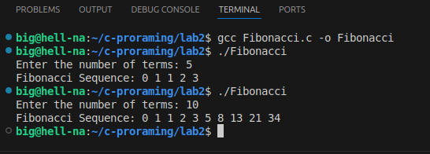

- Write a C program to check whether a number is prime or not.

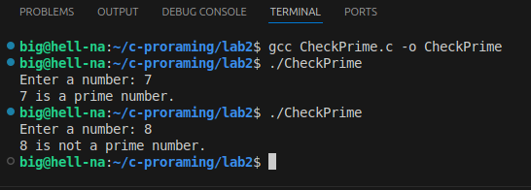

Output:
- Write a C program to to display all the prime numbers up-to n terms.

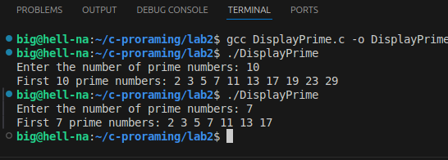
Output:
- Write a C program to to find all the factors of a natural number.

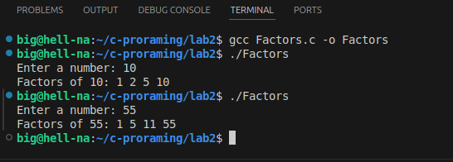
Output:
- Write a C program to find the sum of Fibonacci numbers at Even indexes up to N terms.

Output:
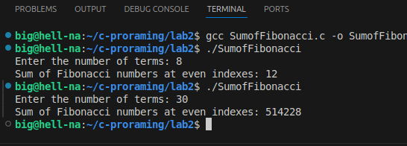

- Write a C program to to find the LCM of two numbers.

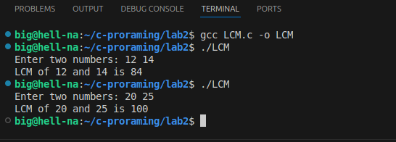

Output:
- Write a C program to check whether the number is neon number.

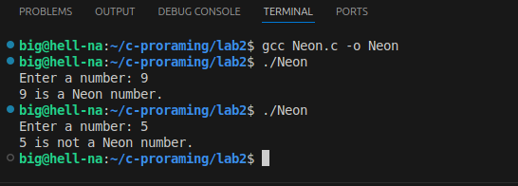

Output:
1.Write a program to take two integers as input from the user and display their sum.

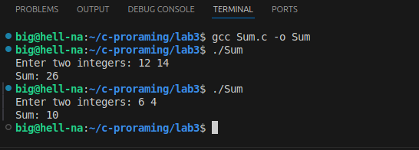

Output:
2. Write a program to take a character as input from the user and display its ASCII value.

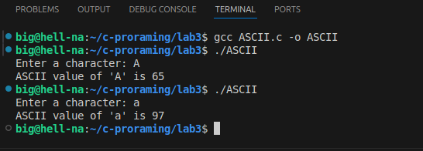

Output:
3. Write a program to take a string as input from the user and display it in reverse order.

Output:

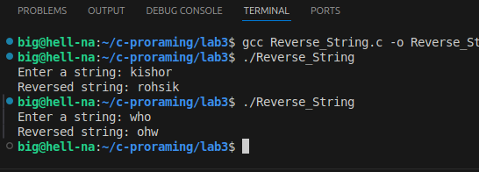

4. Write a program that demonstrates the use of different format specifiers in the printf
function to display various types of data.
Your program should:Print an integer in decimal, octal, and hexadecimal formats.
Print a floating-point number with and without decimal places.
Print a character.Print a string

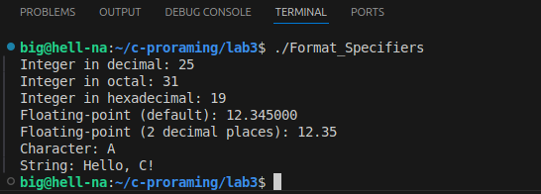
Output:

